## Creating and Customizing Content

**Lab Time**: 75 minutes

**Lab Folder**: C:\Student\Labs\CreatingAndCustomizingContent

**Lab Overview:** In this lab you will use SharePoint Designer 2010 to create a variety of site content. As you perform this lab, notice how you can create the components much quickly and more efficiently using SPD compared to the browser.

Lab Setup Requirements

* Before you begin this lab, you must run the batch file named **SetupLab.bat**. This batch file creates a new blank site collection at the location **http://intranet.wingtip.com/sites/Content**.

### Exercise 1: Create a Subsite and Manage Navigation Options

In this exercise you will first create a subsite and then manage the navigational options for the end users.

1. Using the browser navigate to **http://intranet.wingtip.com/sites/content**.
2. Click **Site Actions » Edit site in SharePoint Designer**. This will open up SharePoint Designer 2010 and will open up the top level site in SharePoint Designer.

**Note:** If SharePoint Designer 2010 does not open and instead you get an advertisement prompting you to download SharePoint Designer, you are using the wrong browser version. The 64-bit version of Internet Explorer can’t launch SharePoint Designer 2010 32-bit. In this case open the site using the 32-bit version of Internet Explorer then repeat the step: **Start » All Programs » Internet Explorer** - don’t pick the (Internet Explorer 64-bit).

1. First thing you are going to do is create a subsite. In the **Subsites** section, Click the **New** button. Use the following information to create a new site in the provided dialog:

**SharePoint Templates**

**Template name:** Team site

**Location of the new Web site:** http://intranet.wingtip.com/sites/content/sales

This dialog will open up a new instance of SharePoint Designer and for the **Sales** site. **Maximize** this window.

1. In the **Site Information** section, click the label **Team Site** for **Title** and change **Team Site** to **Sales**.
2. Then click where it says **<click to enter text>** beside description and change it to **A team site for sales personnel**. Click the **Save** button in the ribbon’s Quick Launch area (at the top of the SharePoint Designer 2010) environment to save your changes.
3. Click the **Web Address URL** to navigate to the site in the browser. Once in the browser, verify the new name and description of the site appears on the page.
4. Go back to **SharePoint Designer 2010**. From here, you are going to configure the navigation options that are available to you in SharePoint Designer.
5. There are two options available in the **Settings** section of SharePoint Designer:
   1. Display Quick Launch
   2. Enable Tree View.
6. Click the check box for **Enable Tree View**. Click the **Save** button at the top left of your screen.

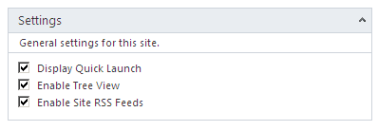

1. Go to the browser and **refresh** the home page of the **Sales** site. You should see the **Tree View** appear under the **Quick Launch**:

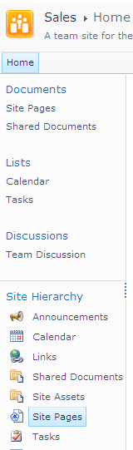

1. Go back to **SharePoint Designer 2010**. This time uncheck the **Display Quick Launch** and **Enable Tree View**. **Save** this page once again.
2. Go to the browser and refresh the home page. Both the **Quick Launch** and also the **Tree View** should now have disappeared.
3. Go back to **SharePoint Designer 2010** environment and in the Sales site summary page, reset the **Quick Launch** by checking the check box to **Display Quick Launch**, and **Save**.

In this exercise you created a new subsite using SharePoint Designer 2010 and made a few customizations to it.

### Exercise 2: Working with Lists

In this exercise you will create a list configure the list's schema.

1. Open **SharePoint Designer 2010** and open the **Sales** site. Click the **Lists and Libraries** option in the **Navigation Pane**.
2. In the ribbon, click **SharePoint List » Contacts**.

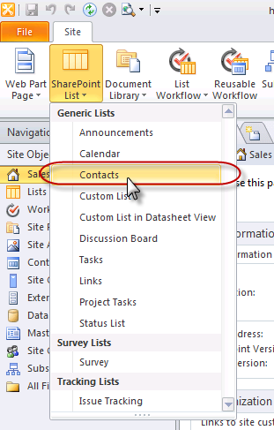

The **Contacts** list does not come as part of the **Team Site**. Many other lists come as part of the team site but Contacts list is something that you have to create if you would like a list of contacts to appear on your site.

1. Name this list **Departmental Contacts** and then click **OK**.
2. **Departmental Contacts** list will automatically open displaying its Summary Page:

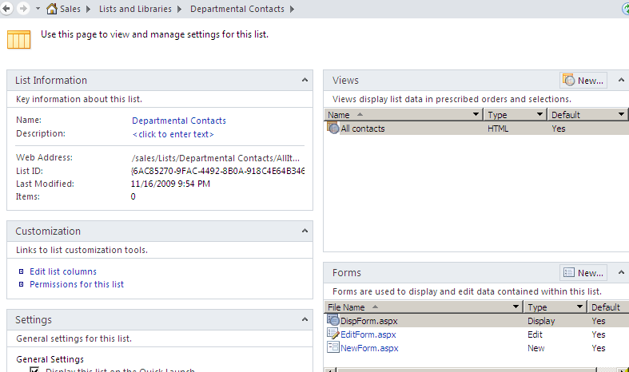

1. Here you see the **Views** for this list, the **Forms** that are available to create new contacts, edit existing contacts and also display contacts. Also you see the **Settings** for the list, the **content types** that are associated to the list and the **Custom Actions** and **Workflows** for this list.
2. In the **Customization** section, there is a link for **Edit list columns**. This will allow you to change the list schema. Click the **Edit list columns**. You should see all the different columns which are available on this list.
3. Since this is a Departmental Contacts list, you do not need the Company column so click the **Company** column name and in the ribbon, click the **Delete** button in the ribbon.
4. You will now add a new column to this list. In the ribbon click **Add New Column » Single Line of Text**. Name the column **Work Email Address**.
5. You can also add existing columns, called Site Columns, to this list. You are going to add a Site Column to the Departmental Contacts list.
6. In the ribbon click **Add Existing Site Column**.
7. In the **Site Columns Picker** look for the **Contact Photo** column, select it and click **OK**.

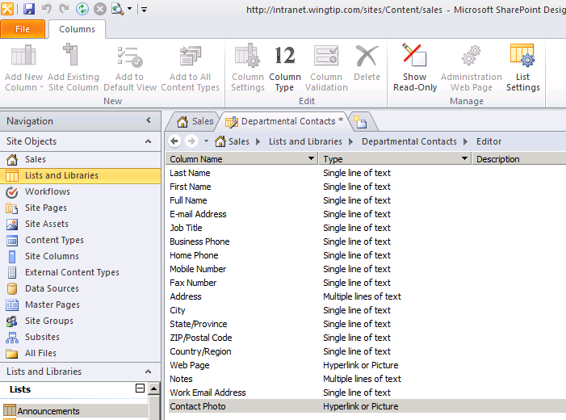

1. Now that you are done configuring the list schema, click the **Save** button at the top.
2. In the ribbon, click **List Settings**. To easily navigate to this list, click the URL beside the **Web Address label**. You should now see the Departmental Contacts list in the browser.
3. The Company column should no longer be there and the new columns, Work Email Address and Contact Photo, should appear.

In this exercise you created a new list and modified it using SharePoint Designer 2010.

### Exercise 3: Working with Images

In this exercise you will explore and work with the options available to work with images in SharePoint pages.

1. You will now add a picture to the **Site Assets** library of the site. Open **SharePoint Designer 2010** and connect to the **http://intranet.wingtip.com/sites/content/sales** site.
2. Click the **Site Assets** library in the Navigation Pane. There should not be any files in this library yet.
3. Drag the file [[LAB FILES]]\StarterFiles\rob.jpg from **Windows Explorer** to the **Site Assets** library in **SharePoint Designer 2010**. The file should now be transferred and should now appear in the **Site Assets** library. At this time, this picture of Rob is available for anyone on the site to use.

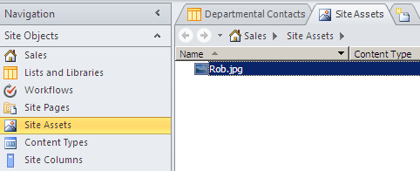

1. Go to the **Sales** site in the browser. Navigate to the contacts list you created earlier by clicking the **All Site Content** in the **Quick Launch**. Then click the **Departmental Contacts** under the **Lists** section.
2. Now create a new item in the list. Click **Add new item**. A dialog box should pop up to ask you to provide information about the new item in the Departmental Contacts list. Use the following to create the new item:

**Last Name**: Walters

**First Name**: Rob

**Full Name:** Rob Walters

**Email Address**:rob@wingtip.com

**Job Title**: Sales Rep

**Contact Photo:**

**Web Address:** /Sites/Content/Sales/SiteAssets/Rob.jpg

**Description:** Rob Walters

The information you have just entered should now appear as a new item in the Departmental Contacts list along with Rob's photo:

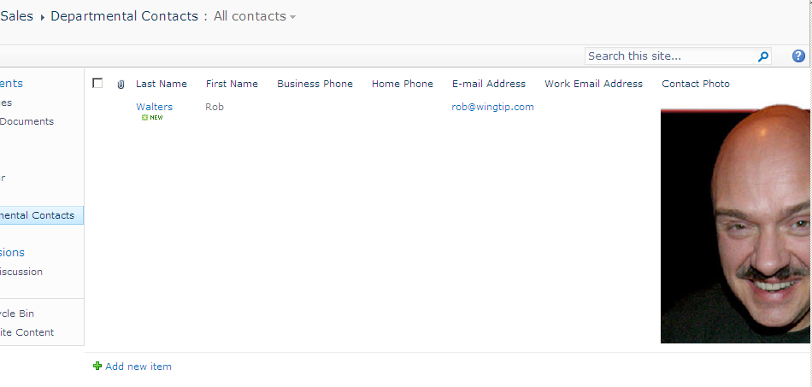

1. As you can see that the picture needs to be resized.
2. From **SharePoint Designer 2010**, select **Lists and Libraries** in the Navigation Pane.
3. Click **Departmental Contacts** list.
4. In the **Views** section, click **All Contacts**.
5. Select the picture decrease the size of the picture to about half the size of the original picture. Click the **Save** icon at the top left.
6. By decreasing the size of this picture, you have decreased the size of the column **Contact Photo**. Any time from now on, a new picture will be added here, it will automatically be sized just like this.

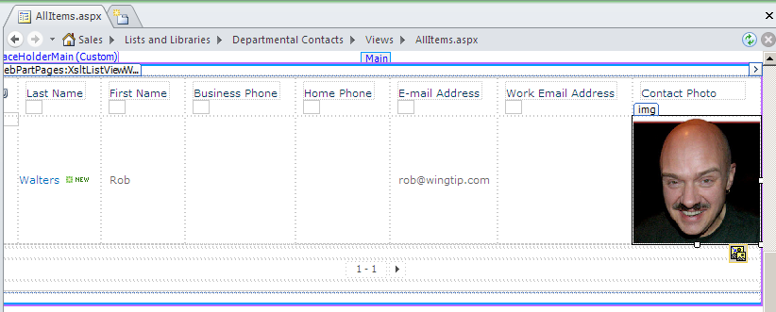

1. Go back to the browser. **Refresh** your view for the **Departmental Contacts** list and the picture should be much smaller now.
2. Add another contact to the list. First upload the picture [[LAB FILES]]\StarterFiles\Michael.jpg using **Windows Explorer** to the **Site Assets Library**.
3. Using the browser, navigate back into the **Departmental Contacts** list, and click the **Add new item** link. Use the following information to create a new contact:

**Last name:** Sullivan

**First name:** Michael

**Full name:** Michael Sullivan

**Email address:** michael@wingtip.com

**Contact Photo**

**Web Address:** /Sites/Content/Sales/SiteAssets/Michael.jpg

**Description**: Michael Sullivan

1. You should see the picture for Michael Sullivan now appear as a new item in the Departmental Contacts list. The picture should be the same dimensions as Rob Walters picture.

In this exercise you created a new list and customized the view using SharePoint Designer 2010.

### Exercise 4: Site Columns and Content Types

In this exercise you will create site columns and content types within a site.

1. Open **SharePoint Designer 2010** and load the **http://intranet.wingtip.com/sites/content/sales** site.
2. Click the **Site Columns** section in the Navigation Pane. In the ribbon, click **New Column » Choice**.

**Name:** Ship Method

**New Group:** AW

1. The next window will prompt you for the choices that you need to populate in this choice site column. **Delete** the existing choices and enter **Fabrikam**, **Contoso** and **F & M Stocks** on separate lines. Set **Contoso** as the **Default** option.
2. Close the **Site Columns** tab by clicking on the **[X]**. In the pop-up asking **Do you want to save the change you just made?** click **Yes**.
3. Now create a new Content Type. Click **Content Types** in the Navigation Pane.
4. Click the **Content Type** button in the ribbon:

**Name:** Sales Order

**Parent content type:** Document Content Types / Document

**New Group:** AW

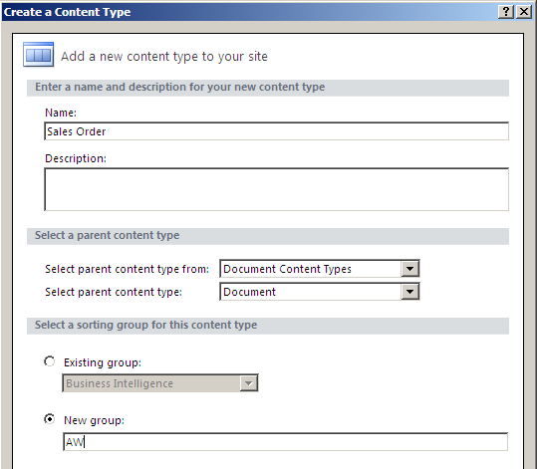

1. Click the **Sales Order** content type in the list of all content types in the site to view the summary page for the newly created content type.
2. In the **Customization** section of the Summary Page, click **Edit content type columns**.
3. In the ribbon select **Add Existing Site Column » Ship Method** (in the AW group). Click the **Save** icon in the ribbon’s Quick Launch. You have now saved the site column under the content type.

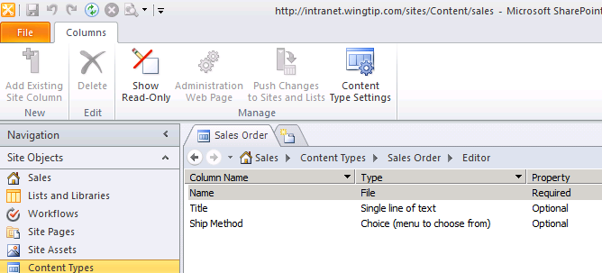

1. You will now create a new document library and then attach this content type to that library. Click the **Lists and Libraries** section in the Navigation Pane. In the ribbon click **Document Library » Document Library**.

**Name:** Sales Order Forms

1. The Sales Order Forms Document library now appears as the list of libraries. Click the link **Sales Order Forms** to see the Summary Page for the Sales Order Forms.
2. To attach a content type to a library, you first need to allow the management of content types. From the **Settings** section of the Summary Page, click the check box for **Allow management of content types**.
3. In the **Content Types** section, click the **Add** button. Select the **Sales Order** content type and click **OK**. Sales Order has become one of the content types available for this Document Library. Click the **Save** icon in the ribbon’s Quick Launch menu.

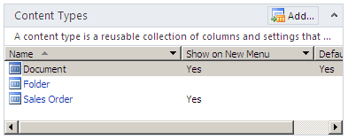

1. To verify that the Sales Order Forms Document library exists and that this content type has been attached to this library, open to the **http://intranet.wingtip.com/sites/content/sales** site in the browser. Click the **Documents** header link, you should now see the **Sales Order Forms** library… select it.
2. In the ribbon, from the **Library Tools** section click **Documents » New Document**. You should see two options:
3. **Document** - which creates a new Word blank document.
   1. **Sales Order** - which creates a new Sales Order type of document.
4. Go back to **SharePoint Designer 2010**. You want to remove the **Document** content type option. In the **Content Types** section, click **Document** which will select the entire row. In the ribbon, click **Show on New Menu** button to toggle it off.
5. The **Sales Order** should now automatically become the new default option and the **Show on New Menu** value should be **Yes**.
6. Go back to the browser. **Refresh** the **Sales Order Forms** document library page. In the ribbon select **Documents » New Document** and you should now see only the Sales Order option:

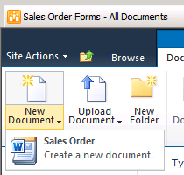

1. You will now associate a document template to the Sales Order content type. Go back to **SharePoint Designer 2010**. Click **Content Types** in the Navigation Pane and select the **Sales Order** content type.
2. To attach a Document Template to this content type, click the **Administration Web Page** button in the ribbon. You should now see the Sales Order Content Types settings page in the browser.
3. Click the **Advanced Settings** link under the **Settings** section.
4. Select the **Upload a new template** radio button and then click the **Browse** button.
5. Select the form **[[LAB FILES]]\StarterFiles\sales-order-form.dotx** which is the Sales Order Form document template. Upload this document to the library.
6. Back at the **Advanced Settings** page in the browser, click the **OK** button. You should now be returned to the Sales Order Content Type settings page and the document template for Sales Orders has been associated with this content type.
7. Click the **Sales Order Forms** under the **Documents** section in **Quick Launch**. In the ribbon click **Documents » New Document » Sales Order**. A new dialog box should pop up to ask you if you want to open this document. Click **OK**.
8. **Microsoft Word 2010** will start and load the order form template.
9. In the **Document Information Panel**, you’ll notice the **Ship Method** site column that is associated with the content type.

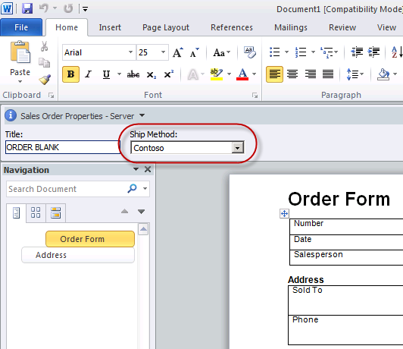

In this exercise you customized a document library by adding a content type and setting it’s document template all from SharePoint Designer 2010!

### Exercise 5: Creating Standard Web Pages

In this exercise you will create standard web pages using SharePoint Designer 2010. These pages are created using SPD, but are not editable by end users.

1. From the browser, click the **Site Pages** link under **Documents** in the **Quick Launch**.
2. Go to **SharePoint Designer 2010**. Click **Site Pages** in the Navigation Pane. You will see the two Wiki pages which already exist in this library.
3. Click **Master Pages** in the Navigation Pane. You will now create a new page that is based upon a Master Page.
4. The Master Page to use is the v4.master. Click **v4.master**. From the ribbon click **Page from Master**.

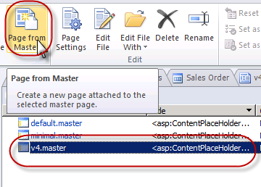

1. The **Select a Master Page** dialog box appears, choose the **Default Master Page** option, and click **OK**.
   1. The **New Web Part Page** dialog box appears:

**Name:** Dept Contacts

**Location:** Site Pages

* 1. You should see a dialog box saying **The page does not contain any regions that are editable in safe mode, do you want to open this page in advance mode?** Click **Yes**.
  2. The page should now appear. In the middle of the page, you should see a **PlaceholderMain**. Select it and click the **chevron (arrow)** that appears to the right of the gray dialog box. From the Common Content Tasks menu, click **Create Custom Content**.

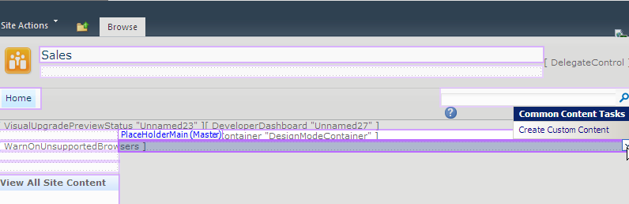

1. Click inside **PlaceholderMain**, you should now be able to put in text or tables or anything else you want to directly on to this page. While the cursor is blinking under the **PlaceholderMain** area, in the ribbon select **Insert » Table » (choose a 1x2 table)**.
2. In the first row, first column of the table, insert the following text: **This page can contain text as well as lists and Web Parts**.
   1. In to the second row, second column, use the ribbon to select **Insert » Web Part Zone**.
3. In the ribbon select **Data View » Departmental Contacts**. The Departmental Contacts should now appear. Click the **Save** icon.

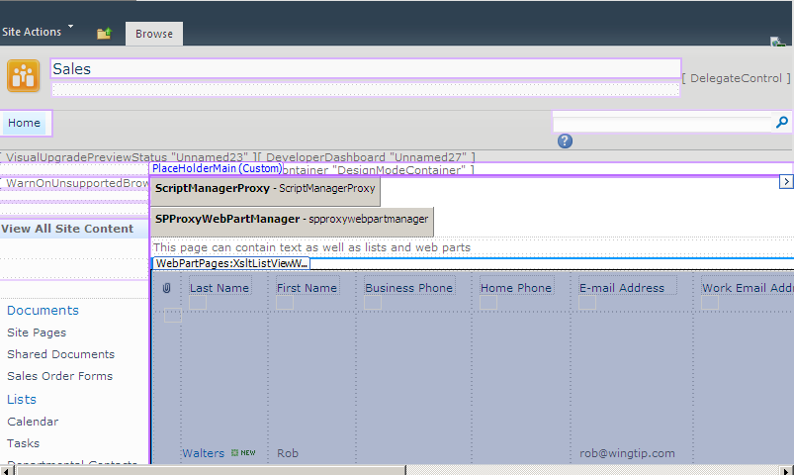

You should see that the pictures of the contacts appear in their normal format, in their normal sizing. You can go ahead and resize the pictures here if you wish.

1. Go back to the browser. Click the **Site Pages** link in the **Documents** section of the **Quick Launch**. Select the **Dept Contacts** page.
2. Now you should see the text that you had put in into the first row first column of that table and also the Departmental Contacts list that you have put in into the second row of the table:

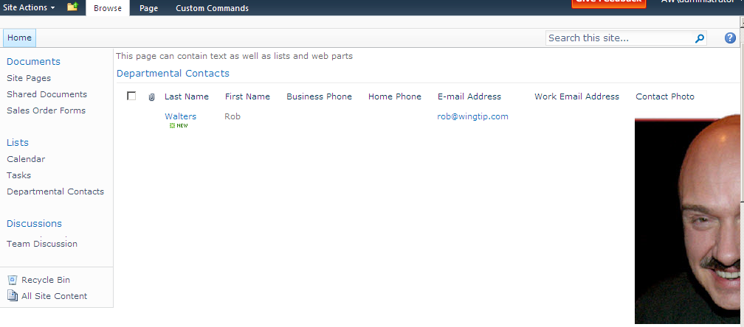

The content page that you just created can contain text, images, lists and Web Parts.

In this exercise you created a new site page based off the site master page using SharePoint Designer 2010.

### Exercise 6: Creating a Web Part Page

In this exercise you will create a Web Part page containing Web Part zones. This type of page can be edited by end users using the browser.

1. You will now create a Web Part page. From **SharePoint Designer 2010** click **Site Pages** in the Navigation Pane.
2. Click the **Web Part Page** button in the ribbon, select the first template in the second row of options and name the file News.aspx.
3. Click News.aspx. You should now see the Summary Page for News.aspx. In the **Customization** section, click the **Edit File** link. News.aspx should now appear in the **Design** view.
4. Notice there are three Web Part zones on the page – first one is **Header**, second one is the **Body** and to the right of the **Body** Web Part zone is the **Right** zone.

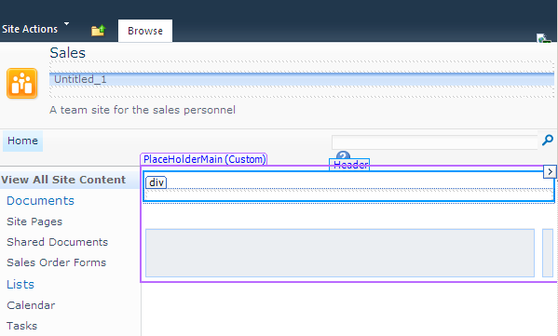

1. Click the **Header** zone. You will insert a new Web Part that is going to be to insert items in the Announcements list. Also you will add another Web Part showing the current announcements in the Announcements list.
2. In the **Header** zone, in the ribbon select **Insert » New Item Form » Announcements** list.
   1. You should now see a single item form for the **Announcements** list appear here along with two buttons - one is for **Save** and the second for **Cancel**.
3. Use the ribbon to select **Data View Tools » Options » Add/Remove Columns**.
4. You need to remove the **Modified** and **Modified By** columns so click **Modified By** column and then the **Remove** button.
5. Repeat the process for the **Modified** column.
6. Finally, click **OK**.
7. Now put your cursor in the **Body** zone and in the ribbon select **Insert » Data View » Announcements**.
8. The current announcements in the Announcements list should now appear. Click the **Save** button.
9. Using the browser, navigate to the **Site Pages** library, click the **News** page. You should now see two Announcements Web Parts: first one is to insert announcement, second one displays the announcements.
10. Click inside the text box with the **Title** and type in the announcement: **New CIO has been selected**. Click the **Save** button. The new announcement should now appear in the Announcements list:

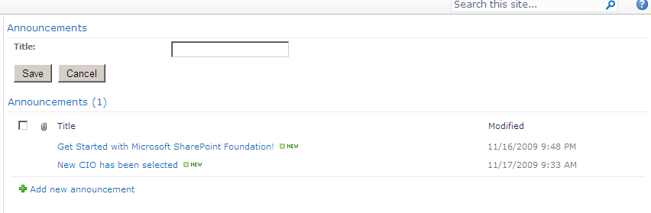

There are also other types of pages you can create in your Team Site.

1. Go to **SharePoint Designer 2010**. Click the **File** tab to get to the backstage page.
2. Click the **Add Item** option. You should see that there are three options here for pages: Web Part Page, New Page from Master, and More Pages.
   1. Click **More Pages**. You should now see all the options that exist to create a page.
   2. You can create HTML, ASPX, CSS, Master Page, JavaScript, XML and Text File type of pages:

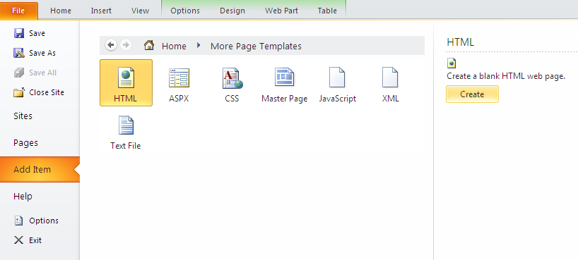

In this exercise you created a new Web Part Page using SharePoint Designer 2010.